Julia for High Performance Computing

Abstract 1
1. Background About Julia 2
1.1. Julia Release History 2
1.2. Julia Key Features 2
2. Getting Started with Julia 4
2.1. Julia Installation Steps 4
Step 1: Download and Install Julia​ 4
Step 2: Open the Julia Command-Line​ 5
Step 3: Add Julia to Jupyter Notebook​ 5
Step 4: Download and Install Anaconda​ and products 5
Step 5: Create a new Notebook​ 6
Step 6: Write your Code​ 6
2.2. Recommended Packages 7
3. Current Real-World Use Cases 9
3.1. Real-World Use Cases In General 9
3.2. Real-World Use Cases In Life Science 10
4. Potential Tasks for High-Performance Computing 12
5. Recommended Julia Readings and References 13
6. Conclusion 13
7. References 13
8. Acknowledgement 14

Abstract
Julia is a high-level, high-performance, dynamic programming language that was designed from the ground up for numerical and scientific computing. This review paper provides an overview of Julia's features and benefits for high-performance computing, including its fast compilation, dynamic typing, multiple dispatch, and built-in support for parallelism. We also discuss current real-world use cases of Julia and potential case studies for high-performance computing, along with recommended readings and references for further exploration.

Background About Julia
Julia is a high-level, high-performance, dynamic programming language that was developed with the goal of combining the ease-of-use of scripting languages like Python and MATLAB with the performance of compiled languages like C and Fortran. It has had many releases since its initial development in 2009.

Julia Release History

Julia was initially developed in 2009 by Jeff Bezanson, Stefan Karpinski, Viral B. Shah, and Alan Edelman, who were motivated by the limitations of existing programming languages in scientific computing and set out to create a free language that was both high-level and fast. The first public release of Julia, version 0.1, was first introduced in 2012 and has since gained popularity in the scientific computing community due to its speed, ease-of-use, and powerful features.

Since then, Julia has undergone several major releases, with new features and improvements added in each release. Version 0.3 was released in August 2014, version 0.6 in June 2017, and both Julia 0.7 and version 1.0 were released on 8 August 2018. Version 1.0 marked a major milestone for Julia, as it was the first stable and production-ready release of the language.

Since the release of version 1.0, Julia has continued to evolve rapidly, with frequent releases of new versions. Versions 1.1, 1.2, 1.3, and 1.4 were released in 2019, while versions 1.5 and 1.6 were released in 2020. Version 1.7 is the latest stable release as of 2022, while versions 1.8 and 1.9 are currently in beta. Julia 2.0 does not yet have a planned release date.

Each release of Julia has introduced new features and improvements to the language, such as improved performance, new syntax, and expanded support for libraries and tools. Julia's development is guided by a strong focus on community involvement, with contributions from a large and active community of users and developers. Julia is open-source software and is licensed under the MIT License, which allows for free and unrestricted use and distribution of the language.

Julia Key Features
Julia's design is optimized for numerical and scientific computing, which makes it popular in research and academia. Its features can be summarized as follows:

- Fast: Julia was designed from the beginning for high performance. Julia programs compile to efficient native code for multiple platforms via Low Level Virtual Machine (LLVM).
- Dynamic: Julia is dynamically typed, feels like a scripting language, and has good support for interactive use.
- Reproducible: Reproducible environments make it possible to recreate the same Julia environment every time, across platforms, with pre-built binaries.
- Composable: Julia uses multiple dispatch as a paradigm, making it easy to express many object-oriented and functional programming patterns.
- General: Julia provides asynchronous I/O, metaprogramming, debugging, logging, profiling, a package manager, and more. One can build entire Applications and Microservices in Julia.
- Open source: Julia is an open-source project with over 1,000 contributors. It is made available under the MIT license. The source code is available on GitHub.

Since Juia is compiled to LLVM which is a compiler infrastructure that provides high-performance code generation for a wide range of platforms. LLVM was originally developed as part of the LLVM project, which aimed to provide a flexible and reusable compiler framework for a range of programming languages. LLVM is used by a variety of programming languages, including Julia, Rust, Swift, and more. In Julia's case, LLVM is used to compile Julia programs to efficient native code that can run on a wide range of platforms.

For more information on Julia's features, here are some helpful links:

- The Julia documentation (https://docs.julialang.org/en/v1/) provides a comprehensive guide to Julia's syntax, features, and package ecosystem.
- The Julia Language: A Concise Introduction (https://arxiv.org/abs/2008.01451) is a paper that provides an introduction to Julia's design and features.
- The Unreasonable Effectiveness of Multiple Dispatch (https://www.youtube.com/watch?v=kc9HwsxE1OY) is a talk by Stefan Karpinski that explains the benefits of Julia's multiple dispatch system.

Julia is a high-performance, dynamic programming language that combines the ease of use of scripting languages with the speed of compiled languages. One of the key features of Julia is its speed, which is achieved through just-in-time compilation and support for multi-threading and distributed computing. Another key feature of Julia is its dynamic type system, which allows for flexible and expressive programming. Julia also supports multiple dispatch, which makes it easy to express many object-oriented and functional programming patterns. Other features of Julia include metaprogramming, asynchronous I/O, reproducible environments, and support for machine learning and data analysis through packages such as Flux.jl and DataFrames.jl. Julia is used by over 10,000 companies and over 1,500 universities, and has been applied in various fields, including machine learning, data science, scientific computing, finance, robotics, and materials science ,,,, .

Getting Started with Julia
To get started with Julia, one can download the latest stable release of Julia from the official website (https://julialang.org/downloads/). Julia has a simple and intuitive syntax that is easy to learn for users familiar with programming languages such as Python or MATLAB. Julia's package manager, Pkg, makes it easy to install and manage packages, which are libraries of code that extend Julia's functionality.

Julia Installation Steps
Here are the main steps for installing Julia and Jupter:

Step 1: Download and Install Julia​
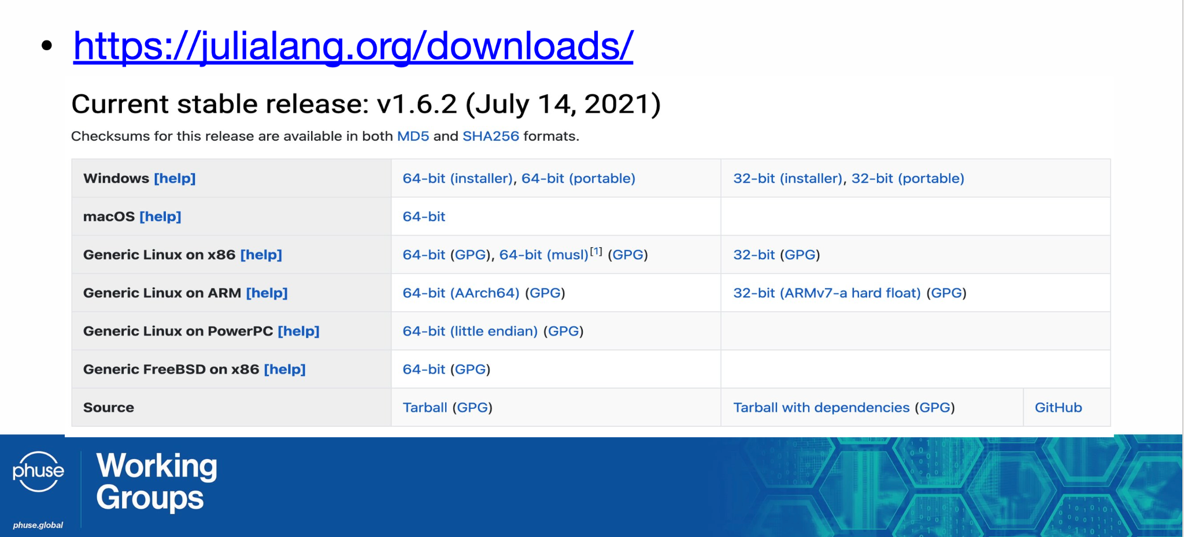

Step 2: Open the Julia Command-Line​
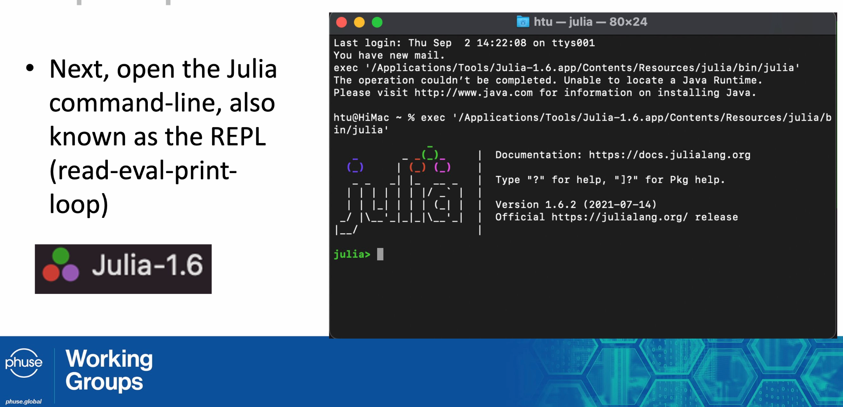

Step 3: Add Julia to Jupyter Notebook​
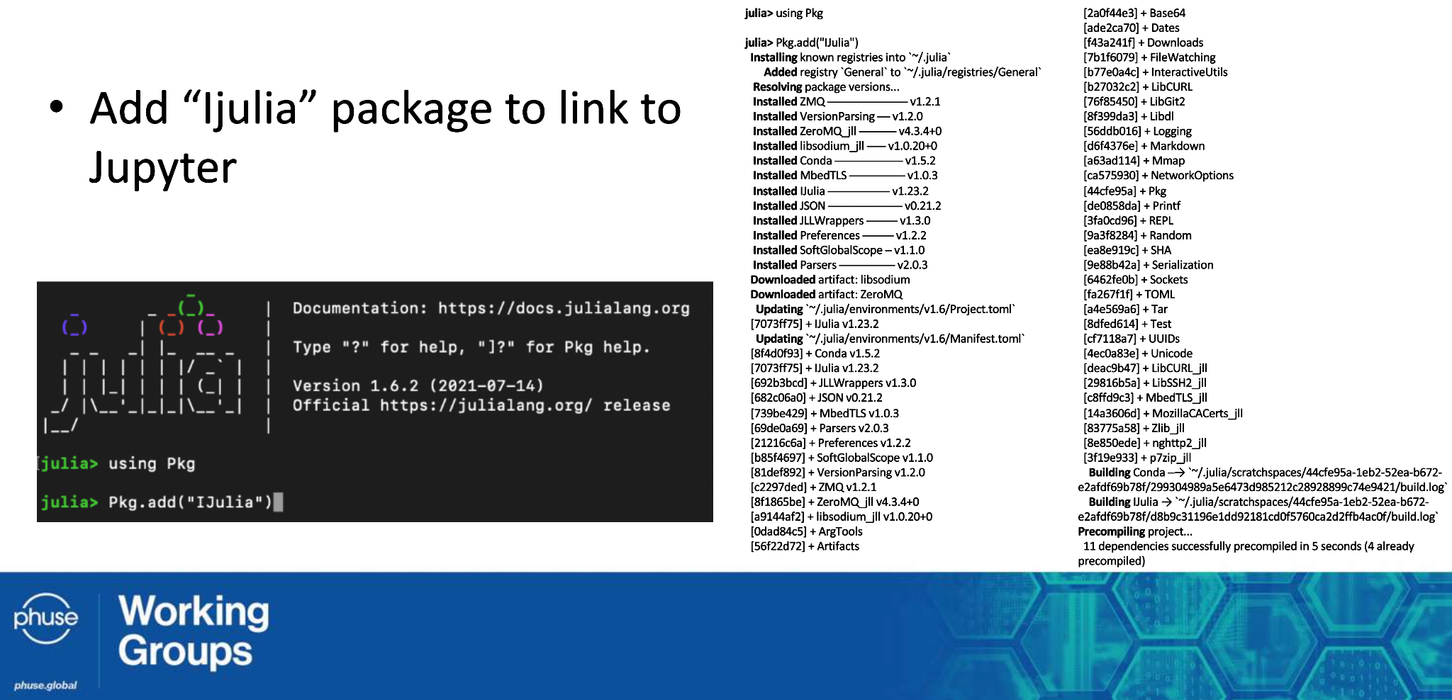

Step 4: Download and Install Anaconda​ and products
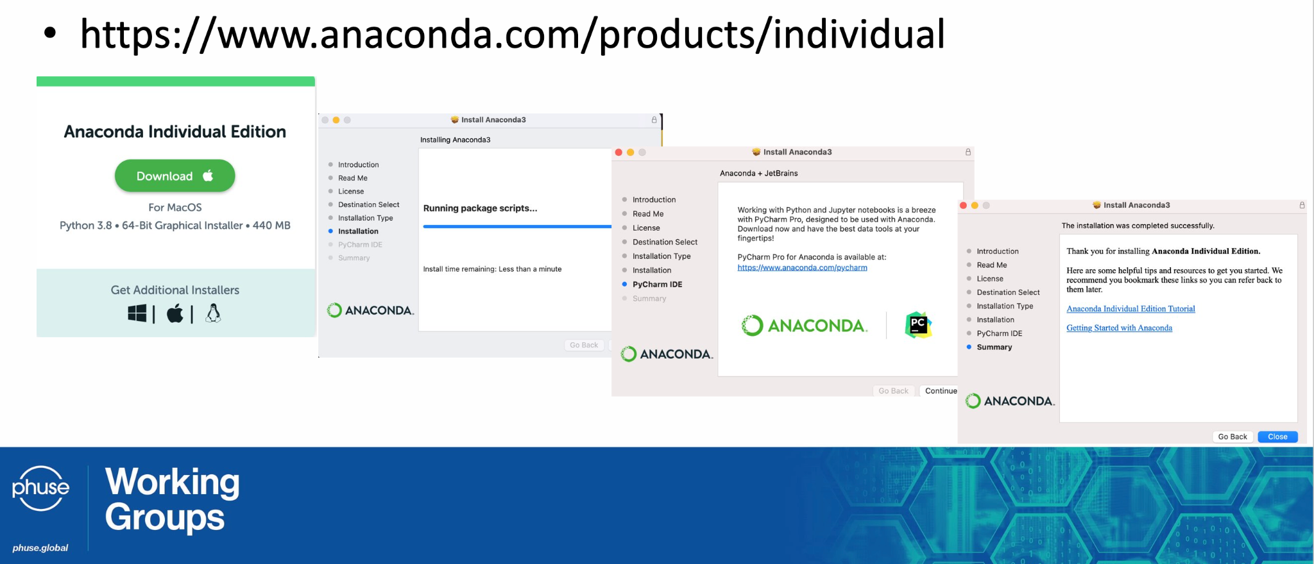
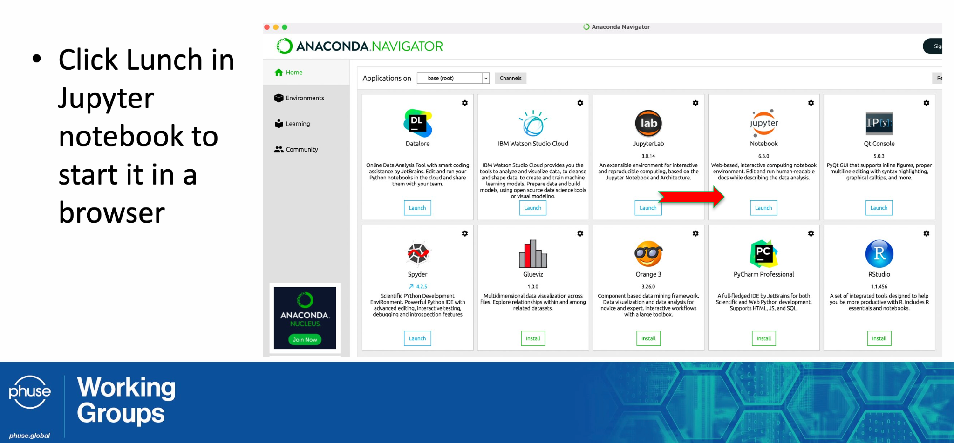

Step 5: Create a new Notebook​
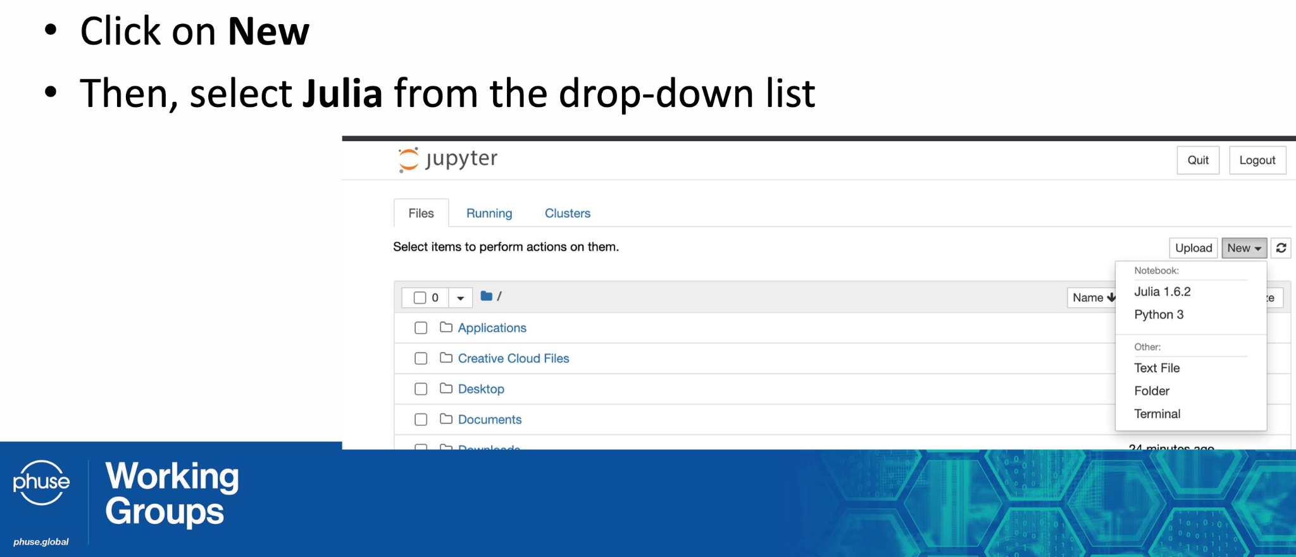

Step 6: Write your Code​
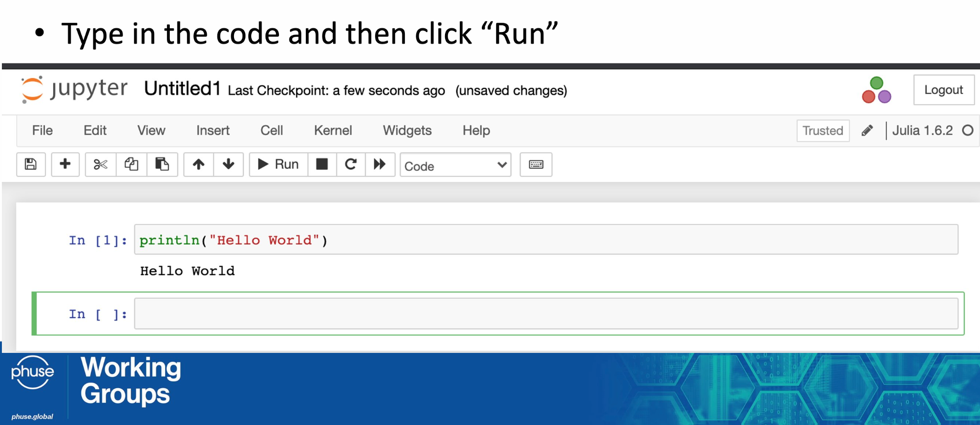

Recommended Packages

Some recommended packages for high-performance computing include:

- LinearAlgebra: provides a wide range of matrix and vector operations, including eigenvalue decomposition and singular value decomposition. Here are some examples:
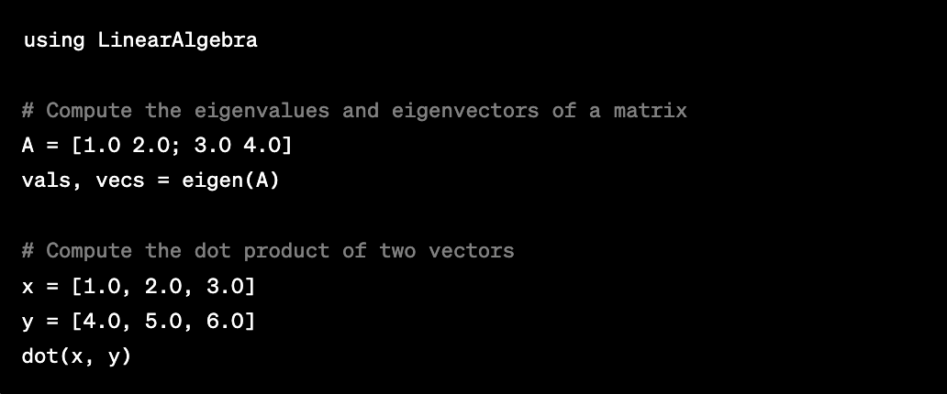
- Statistics: provides statistical functions for data analysis and modeling, including probability distributions, hypothesis testing, and regression analysis. This package is built-in to Julia, so no additional installation is required. Here are some example usages:
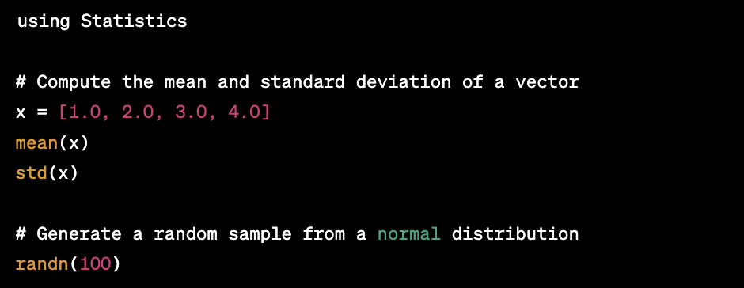
- Distributed: provides support for distributed computing, allowing Julia code to run on multiple processors or nodes.
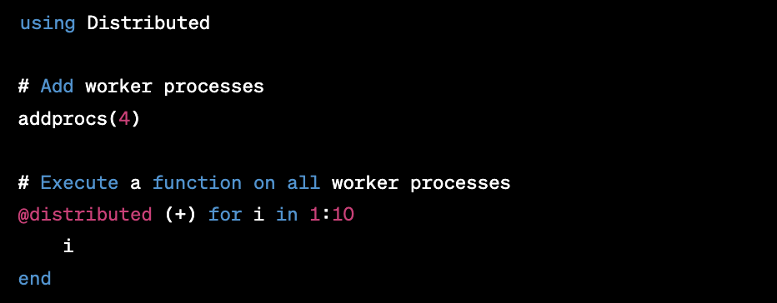
- CUDA: provides support for GPU computing using the CUDA programming model.
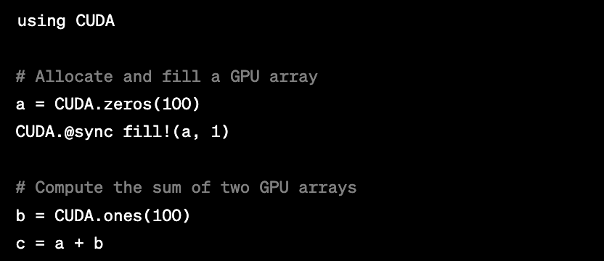

Compute Unified Device Architecture (CUDA) is a parallel computing platform and application programming interface (API) developed by NVIDIA that allows developers to harness the power of NVIDIA GPUs for high-performance computing tasks. CUDA provides a C/C++-like language for programming NVIDIA GPUs, as well as a set of libraries and tools for optimizing and debugging GPU code.

The power of CUDA comes from the massively parallel architecture of NVIDIA GPUs. While CPUs are designed to perform a small number of tasks quickly and efficiently, GPUs are designed to perform a large number of simpler tasks in parallel. This makes GPUs well-suited for high-performance computing tasks such as scientific simulations, machine learning, and data processing.

By using CUDA, developers can write code that runs on the GPU in parallel, taking advantage of the many cores available on modern GPUs. This can lead to significant speedups compared to running the same code on a CPU. For example, deep learning algorithms that might take days or weeks to train on a CPU can be trained in hours or even minutes on a GPU using CUDA.

In Julia, the CUDA.jl package provides support for using CUDA in Julia code. With CUDA.jl, developers can write GPU-accelerated code in Julia using familiar syntax and idioms, while still taking advantage of the power of CUDA. This makes it easy for Julia developers to harness the power of NVIDIA GPUs for high-performance computing tasks.

Current Real-World Use Cases
Julia is increasingly being used in real-world applications. It is currently one the 12 languages to know for data science along with Python, R, SQL, C/C++, Java, JavaScript, Go, Scala, Swift, Matlab and SAS. Julia[1] is fast and flexible and this has made it a goto language for processing big data. Let’s see some use cases in general and then specific use cases within life science.

Real-World Use Cases In General

Julia is becoming an increasingly popular choice for scientific computing and data analysis due to its speed, ease-of-use, and powerful features. Here are some real-world use cases that highlight the capabilities of Julia in various fields:

- Machine Learning: Julia's speed and flexibility make it well-suited for developing machine learning models. For example, the Flux.jl package (https://fluxml.ai/) provides a suite of tools for deep learning and other machine learning tasks in Julia. Julia has also been used for developing models for natural language processing, image recognition, and other applications. You can see examples of Julia in data science for machine learning, data visualization, and data manipulation (https://juliacomputing.com/case-studies/data-science.html).
- Finance: Julia's speed and support for distributed computing make it well-suited for financial modeling and data analysis. For example, the QuantEcon.jl package (https://quantecon.org/quantecon-jl/) provides a suite of tools for quantitative economics and finance in Julia. Julia has also been used for developing trading algorithms, risk management models, portfolio optimization, and trading strategies (https://juliacomputing.com/case-studies/finance.html).
- Robotics: Julia has been used for developing control systems for robots and other autonomous systems. For example, the RobotOS.jl package (https://github.com/jdlangs/RobotOS.jl) provides a set of tools for robot control and simulation in Julia. Julia has also been used for developing reinforcement learning models for robotic control.
- Aerospace Engineering: Julia's speed and support for distributed computing make it well-suited for large-scale simulations in aerospace engineering. For example, the ModelingToolkit.jl package (https://mtk.sciml.ai/stable/) provides a set of tools for modeling and simulating aerospace systems in Julia. Julia has also been used for developing control systems for drones and other unmanned aerial vehicles. NASA's Jet Propulsion Laboratory uses Julia to simulate spacecraft trajectories and optimize mission designs (https://juliacomputing.com/case-studies/nasa-jpl.html).
- Materials Science: Julia has been used for modeling and simulating materials properties and behavior. For example, the MaterialsProject.jl package (https://materialsproject.github.io/MaterialsAPI.jl/) provides a suite of tools for materials research and analysis in Julia. Julia has also been used for developing machine learning models for predicting materials properties.
- Scientific Computing: Julia is used in scientific computing for numerical simulations, computational physics, and computational chemistry (https://juliacomputing.com/case-studies/scientific-computing.html). Julia's support for distributed computing and parallelism make it well-suited for high-performance data processing tasks, such as real-time data analytics and large-scale data processing. For example, the JuliaDB.jl package (https://juliadb.org/) provides a fast and flexible database system for Julia.
- Scientific Simulations: Julia is a popular choice for scientific simulations, such as computational fluid dynamics, astrophysics, and quantum mechanics. For example, the QuantumOptics.jl package (https://qojulia.org/) provides a toolkit for simulating quantum optics systems using Julia.

These are just a few examples of the many ways that Julia is being used in scientific computing and data analysis. The speed, flexibility, and ease-of-use of Julia make it a powerful tool for tackling a wide range of computational tasks.

Real-World Use Cases In Life Science
Julia is becoming an increasingly popular choice for scientific computing due to its speed, ease-of-use, and powerful features. Here are some real-world use cases that highlight the capabilities of Julia in life science:

- Modeling Infectious Diseases: Julia has been used to model the spread of infectious diseases, such as COVID-19. For example, the COVIDAnalytics.jl package (https://github.com/m3dev/covid-analytics-julia) provides a toolkit for analyzing COVID-19 data using Julia. Researchers have also used Julia to model the transmission dynamics of other infectious diseases, such as Ebola.
- Genomics: Julia is well-suited for genomics data analysis due to its speed and support for distributed computing. For example, the BioJulia project (https://biojulia.net/) provides a suite of packages for genomics data analysis in Julia. Julia has also been used for genome assembly and annotation, as well as for analyzing large-scale genomic datasets.
- Drug Discovery: Julia's speed and flexibility make it well-suited for drug discovery tasks, such as virtual screening and molecular docking. For example, the MolSim.jl package (https://molsimjl.readthedocs.io/en/latest/) provides a suite of tools for molecular simulation and drug discovery in Julia. Julia has also been used to develop machine learning models for predicting drug efficacy and toxicity.
- Neuroscience: Julia has been used for modeling neural systems, analyzing neuroimaging data, and developing machine learning models for brain-computer interfaces. For example, the NeuroJulia project (https://github.com/JuliaNeuroscience) provides a collection of packages for neuroscience research in Julia. Julia has also been used for developing deep learning models for brain-inspired computing.
- Climate Modeling: Julia's speed and support for parallel computing make it well-suited for climate modeling tasks, such as simulating the effects of climate change on ecosystems and predicting extreme weather events. For example, the ClimateMachine.jl package (https://climatemachine.github.io/ClimateMachine.jl/stable/) provides a suite of tools for climate modeling in Julia.

These are just a few examples of the many ways that Julia is being used in life science research. The speed, flexibility, and ease-of-use of Julia make it a powerful tool for tackling a wide range of scientific computing tasks. There are several companies that have started using Julia to perform various tasks. Here are some examples:

- Pfizer: Pfizer used Julia to accelerate the simulation of treatments for heart failure by 175 times using models running in Julia[2].
- AstraZeneca: AstraZeneca uses Bayesian neural networks with the Flux.jl and Turing.jl Julia packages to predict drug toxicity [2].
- Julia Computing: Julia Computing is a company founded by the creators of Julia that offers commercial support and services for Julia. Julia Computing has raised $24 million in Series A funding and is used by over 10,000 companies and over 1,500 universities [3].

These are just a few examples of companies that are using Julia to perform various tasks. The popularity and adoption of Julia in industry and academia continues to grow, with companies and organizations of all sizes recognizing the benefits of using Julia for high-performance computing tasks,, ([4][5][6]).

Potential Tasks for High-Performance Computing
Julia's speed, flexibility, and ease-of-use make it well-suited for a wide range of high-performance computing tasks in life science. Here are some potential case studies for using Julia in life science:

- Genome Assembly: Julia's support for distributed computing and parallel processing make it well-suited for genome assembly tasks, which involve assembling long DNA sequences from shorter reads. With Julia, researchers can efficiently process and analyze large-scale genomics datasets to generate accurate genome assemblies.
- Protein Folding: Protein folding is a complex computational problem that involves predicting the three-dimensional structure of a protein based on its amino acid sequence. Julia's speed and support for machine learning make it well-suited for developing accurate and efficient models for protein folding, which could have implications for drug discovery and other areas of research.
- Disease Diagnosis: Julia's speed and support for machine learning make it well-suited for developing models for disease diagnosis based on patient data, such as medical imaging or genomic data. With Julia, researchers can efficiently analyze and process large-scale datasets to develop accurate and reliable models for disease diagnosis.
- Drug Discovery: Julia's speed and flexibility make it well-suited for virtual screening and molecular docking tasks in drug discovery, which involve screening large databases of compounds to identify potential drug candidates. With Julia, researchers can efficiently screen large-scale databases and develop accurate and efficient models for predicting drug efficacy and toxicity.
- Neuroscience: Julia's support for distributed computing and machine learning make it well-suited for developing models of neural systems and analyzing large-scale neuroimaging datasets. With Julia, researchers can efficiently process and analyze large-scale neuroimaging datasets to develop accurate models of neural systems, which could have implications for understanding brain function and developing new therapies for neurological disorders.

These are just a few examples of the many potential case studies for using Julia in life science research. The speed, flexibility, and ease-of-use of Julia make it a powerful tool for tackling a wide range of computational tasks in life science.

Recommended Julia Readings and References
For further exploration of Julia and high-performance computing, here are some recommended readings and references:

- The Julia Documentation (https://docs.julialang.org/en/v1/) provides a comprehensive guide to Julia's syntax, features, and package ecosystem.
- Julia Academy (https://juliaacademy.com/) provides online courses and tutorials on Julia for beginners and advanced users.
- The JuliaCon Conference (https://juliacon.org/) is an annual conference that showcases the latest developments and applications of Julia.
- "Julia: A Fresh Approach to Numerical Computing" (https://arxiv.org/abs/1411.1607) is a paper by the creators of Julia that provides an overview of the language's design and features.
- "The Unreasonable Effectiveness of Multiple Dispatch" (https://www.youtube.com/watch?v=kc9HwsxE1OY) is a talk by Stefan Karpinski that explains the benefits of Julia's multiple dispatch system.

Conclusion
In conclusion, Julia is a powerful and versatile programming language that offers many features and benefits for high-performance computing. With its fast compilation, dynamic typing, multiple dispatch, and built-in support for parallelism, Julia is becoming an increasingly popular choice for scientific simulations, machine learning, and high-performance data processing. This review paper provides an introduction to Julia's features and benefits for high-performance computing, along with practical guidance on getting started with Julia, real-world use cases, potential case studies, and recommended readings and references.

References
- [1] "Julia’s power has especially made it a go-to option for big data analysis in the private sector and scientific research. The language can be found in noteworthy projects for climate modeling, weather forecasting and astronomical surveys, among others. Its wide-ranging interoperability — compatible with everything from Python to old-school Fortran — and its continued boost from MIT, also make Julia a likely long-term contender."
URL: 12 Top Data Science Programming Languages 2023 | Built In
- URL: https://www.datacamp.com/blog/the-rise-of-julia-is-it-worth-learning-in-2022 [2] "Data Teams Using Julia. It's not just aerospace engineering—pharmaceutical companies are developing with Julia as well. Pfizer accelerated the simulation of treatments for heart failure 175 times using models running in Julia. AstraZeneca uses Bayesian neural networks with the Flux.jl and Turing.jl Julia packages to predict drug toxicity."
URL: https://www.datacamp.com/blog/the-rise-of-julia-is-it-worth-learning-in-2022
- [3] "Julia solves the two language problem by providing high performance and ease of use in a single language. Julia is used by over 10,000 companies and over 1,500 universities. Julia's creators won ..."
URL: https://www.prnewswire.com/news-releases/julia-computing-raises-24m-in-series-a-former-snowflake-ceo-bob-muglia-joins-board-884269978.html
- [4] "It is taught at hundreds of universities and entire companies are being formed that build their software stacks on Julia. From personalized medicine to climate modeling, novel materials and even space mission planning — everywhere you look, the Julia community is pushing the boundaries of human discovery."
URL: https://julialang.org/blog/2022/02/10years/
- [5] "The Julia language was first introduced in 2012 by a team of developers led by Jeff Bezanson, Stefan Karpinski, Viral B. Shah, and Alan Edelman. Since its inception, Julia has been used in various fields, including machine learning, data science, and scientific computing."
URL: https://leftronic.com/blog/julia-programming-language/
- [6] "One of the popular packages is JuliaFin, which specializes in areas such as asset management, risk management, algorithmic trading, backtesting, and other areas of computational finance, including modeling financial contracts. 9. Robotics Roboticists from MIT use Julia to program robots."
URL: https://www.datacamp.com/blog/what-is-julia-used-for

Acknowledgement
This white paper was developed by the Julia Initiative for High-Performance Computing project in the Data Visualization and Open Source Technology (DVOST) working group. Thanks to the following key members who participated in the initial discussion and in drafting this white paper:
- Hanming Tu (htu@ashandainc.com)
- Chris Hurley (churley@mmsholdings.com)
- Melvin Munsaka (melvin.munsaka@abbvie.com)
- Patrick Hannon (phannon@mmsholdings.com)
- Jeff Mills (millsjf@ucmail.uc.edu)
Thanks to Paula Rowley in assisting all the initial meetings!

Julia Computing Raises $24M in Series A, Former Snowflake CEO Bob Muglia Joins Board
The Rise of the Julia Programming Language — Is it Worth Learning in 2022? | DataCamp
Why We Use Julia, 10 Years Later
The Julia Programming Language: The History and Uses
What is Julia Used For? 10 Applications of Julia Programming | DataCamp
12 Top Data Science Programming Languages 2023 | Built In
Why We Use Julia, 10 Years Later
The Julia Programming Language: The History and Uses
Julia Computing Raises $24M in Series A, Former Snowflake CEO Bob Muglia Joins Board
What is Julia Used For? 10 Applications of Julia Programming | DataCamp
Why We Use Julia, 10 Years Later

