{2025-DEC-17}

Capturing Computational Workflows in Clinical Trials with BioCompute

Revision History
Version | Date | Summary
1.0 | 2025-DEC-17 | Original Version

Table of Contents
1: Overview: Purpose of this document 3
2: Scope: 3
3: Definitions: 4
4: Problem Statement: 5
5: Background: 5
Introduction of the BioCompute Framework 5
Structure of a BioCompute Object 5
BioCompute Object Database (BCODB) 7
Tools and Platform Integrations 8
Pilot Project and FDA Adoption 8
6: Case studies: 9
Multi-Omics Cancer Prognosis Model 9
Clinical Trial with Transcriptomics and Proteomics Data 10
Clear Cell Renal Cell Carcinoma Glycoproteomic Risk Prediction 10
Clinical Trial with Imaging Protocol Endpoints 11
7: Recommendation: 12
8: Disclaimer: 13
9: References: 14
10: Project Contact Information: 15
11: Acknowledgments: 15

1: Overview: Purpose of this document
This white paper explores the emerging role of the BioCompute standard (IEEE 2791-2020, [1]) in clinical trials. It presents practical applications through real-world case studies, aiming to enhance understanding among data scientists, regulatory agency personnel, and other professionals involved in the design, execution, and review of computational workflows in clinical research.
The document showcases BioCompute implementation across a range of clinical and computational contexts, demonstrating its ability to support complex data types – such as omics and imaging – and its integration into diverse computational platforms. It illustrates how BioCompute enhances reproducibility, transparency, and collaboration by enabling structured, auditable documentation of computational methods.
The aim is to foster continued engagement with the BioCompute framework and support its broader adoption and evolution within clinical research.

2: Scope:
This document examines the application of the BioCompute framework in clinical research, focusing on:
- Clinical trial integration: Using BioCompute to improve transparency and repeatability in data analysis workflows.
- Regulatory submissions: Applying BioCompute to document computational procedures, supporting improved quality and efficiency in submissions to regulatory authorities.
- Complex data processing: Leveraging BioCompute to document analysis pipelines for omics and imaging data.
- Tools and platforms: Highlighting platforms and open-source packages that facilitate BioCompute implementation.
The target audience includes clinical data scientists, regulatory agency personnel, and other people with an interest in standardization of workflow communication.

3: Definitions:
Table 1 Definitions
Term | Definition
API | Application Programming Interface
BCO | BioCompute Object
BCODB | BioCompute Object Database
BRCA | Breast Cancer Gene
CBER | Center for Biologics Evaluation and Research
ccRCC | Clear Cell Renal Cell Carcinoma
CDISC | Clinical Data Interchange Standards Consortium
CDER | Center for Drug Evaluation and Research
Cox-PH | Cox-Proportional Hazards
CWL | Common Workflow Language
eCTD | Electronic Common Technical Document
FDA | Food and Drug Administration
GEO | Gene Expression Omnibus
GxP | Good Practice within a particular field, such as GCP (Good Clinical Practice)
HCC | Hepatocellular Carcinoma
HFP | Human Foods Program
HIVE | High-performance Integrated Virtual Environment
JSON | JavaScript Object Notation
LASSO | Least Absolute Shrinkage and Selection Operator
METABRIC | Molecular Taxonomy of Breast Cancer International Consortium
Omics | The collective characterization and quantification of entire sets of biological molecules, such as genomics, proteomics, metabolomics, and transcriptomics
ROI | Region of Interest
SDTM | Study Data Tabulation Model
TCGA | The Cancer Genome Atlas
TMT | Tandem Mass Tag
URI | Uniform Resource Identifier

4: Problem Statement:
Modern bioinformatics workflows are increasingly complex, involving diverse data types, evolving tools, and multi-step analyses. Yet documentation practices remain inconsistent, making it difficult to reproduce results, assess data provenance, or meet regulatory expectations. The existing CDISC standards for structuring clinical trial data do not provide mechanisms for documenting computational workflows associated with complex biomedical data types.
Consistent workflow communication requires a shared understanding and approach between industry and regulatory authorities. BioCompute provides a structured framework well-suited for this purpose, enabling reproducible documentation of computational analyses.

5: Background:

Introduction of the BioCompute Framework
Over the past years, the increasing complexity of bioinformatics pipelines has made it difficult to consistently document and reproduce analyses. Without a standardized approach, workflow descriptions are often fragmented, ad hoc, and insufficient for review or replication.
The BioCompute standard for workflow documentation was developed to address these challenges. Starting from an idea conceived in 2012, the standard has been developed as a collaboration between George Washington University and the US Food and Drug Administration (FDA) with input from a wide range of contributors from public and private sectors. In 2020, BioCompute was formally recognized as an IEEE standard (IEEE 2791-2020) [2 - 4].
BioCompute provides a formalized approach for capturing the full context of a computational workflow, including metadata, inputs, parameters, execution environment, and outputs. Rather than replacing existing standards, BioCompute complements them by acting as a communication layer that improves transparency and reproducibility. Detailed BioCompute guidance and resources are available via the BioCompute Portal [5].

Structure of a BioCompute Object
A BioCompute Object (BCO), an instance of the BioCompute standard, is a machine-readable record of workflow documentation in JSON format [6]. The JSON structure is organized into sections known as domains, each serving a specific purpose in documenting the workflow.
The domains include:
- Provenance Domain: BCO metadata, including version, status, and contributors.
- Usability Domain: A free-text field used to describe the purpose and context of the analysis.
- Description Domain: Analysis step outline with step inputs and outputs.
- Parametric Domain (optional): List of parameters used to customize the computational flow.
- Input and Output Domain: List of global input and output files.
- Execution Domain: Computational environment description.
- Extension Domain (optional): User-defined information that is not defined in the standard BioCompute structure.
- Error Domain (optional): Definition of workflow-specific empirical and algorithmic error tolerances.
A BCO example is shown in Figure 1.
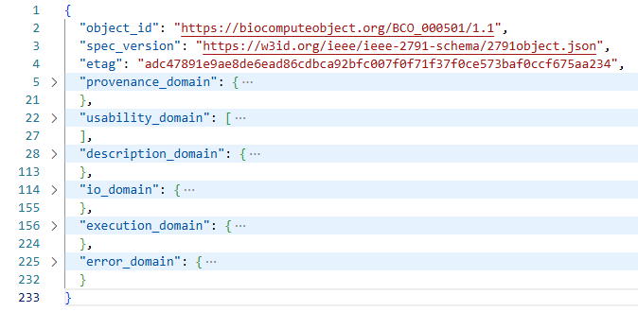
Figure 1 BCO example with the required domains plus the optional Error Domain in collapsed view

BioCompute Object Database (BCODB)
To support the storage, management, and sharing of BioCompute Objects (BCOs), a centralized BioCompute Object Database (BCODB) has been established [7]. This secure, access-controlled system allows organizations to manage BCOs under assigned, organization-specific prefixes, with configurable user permissions, such as reading, writing, publishing, and sharing.
Resources within the BCODB are available through well-documented Application Programming Interface (API) endpoints to facilitate automation and integration with external applications [8]. This includes endpoints for creating, retrieving, updating, and validating BCOs, see Figure 2.

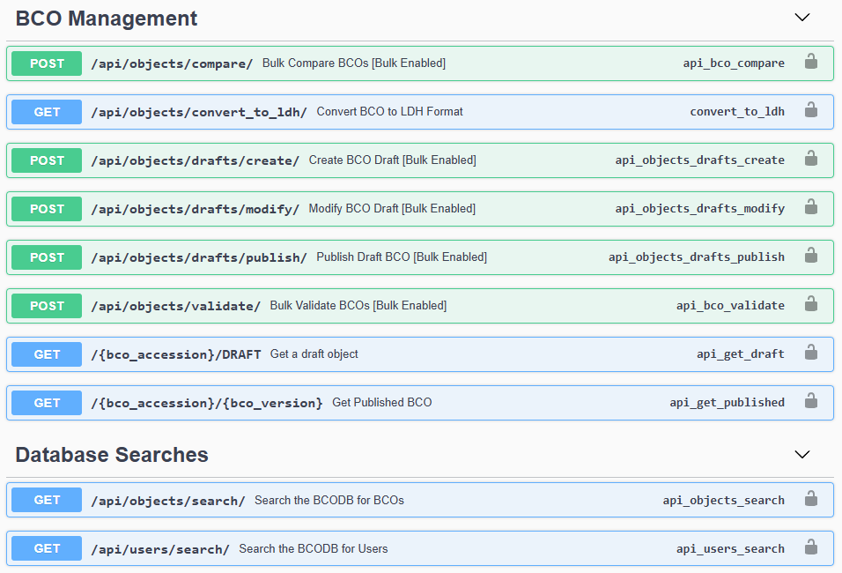
Figure 2 A subset of the BCODB API endpoints

Tools and Platform Integrations
BioCompute has been integrated into a range of bioinformatics platforms and tools, enabling users to generate, export, and manage BCOs directly from their workflows:
- BioCompute Builder: A platform-free, form-based editor for BioCompute creation [9].
- Galaxy: An open-source, web-based platform for data intensive biomedical research that allows users to export workflows as BCOs [10].
- Seven Bridges Cancer Genomics Cloud: Provides the BCO App, which supports BCO generation from user workflows, with visualization support and direct submission to the BCODB [11,12].
- DNAnexus: Offers the BCOnexus app, which can generate BCOs from DNAnexus or PrecisionFDA workflows. The app supports common workflow language, CWL, and includes API connectivity to BCODB for saving, sharing, and importing BCOs [13].
- HIVE: The High-performance Integrated Virtual Environment computing environment supports workflow-based BCO creation [14].
- Nextflow: A scientific workflow system that enables BCO creation from Nextflow pipelines [15,16].
- The whirl package: An open-source R package developed by Novo Nordisk that enables users to create BCOs in connection with script execution using input from a YAML configuration file [17].

Pilot Project and FDA Adoption
To evaluate and expand the usability of BCOs, a pilot project was conducted in collaboration with three pharmaceutical companies and the FDA’s Center for Biologics Evaluation and Research (CBER) and Center for Drug Evaluation and Research (CDER). The project addressed logistical aspects of including BCOs in the electronic Common Technical Document (eCTD) submission package and explored how BCOs could streamline the submission and review process. It resulted in a comprehensive FAQ covering topics such as BCO content, formatting, and placement within regulatory submissions [18].
As of today, CBER, CDER, and the Human Foods Program (HFP) accept BCOs as part of regulatory submissions [19].

6: Case studies:
This section presents selected case studies that demonstrate how BCOs have been applied to document complex bioinformatics workflows in clinical contexts. These examples illustrate how BioCompute can be integrated into diverse data environments – from multi-omics and imaging to machine learning pipelines.
Each case highlights a different use scenario, offering practical insights into how BioCompute supports workflow documentation, regulatory readiness, and collaborative research.

Multi-Omics Cancer Prognosis Model
This case study demonstrates how BioCompute was used to document the application of DeepProg [20] for cancer prognosis modeling across 32 cancer types. DeepProg is an ensemble framework of deep-learning and machine-learning approaches that predicts patient survival subtypes using multi-omics data. By transforming RNA-seq, miRNA, and DNA methylation data into survival-associated features, the model enables patient clustering and outcome prediction.
The BCO provides a versioned record of the entire workflow, including modeling framework, model tuning, data sources and outputs. This example demonstrates how BioCompute facilitates the translation of advanced modeling techniques into clinical practice by providing a framework that supports replicability and compliance review.
The BCO can be explored in JSON format [21] or via a viewer [22]. It ties together:
- What ran: Python3 with scikit-optimize v0.8.1, Ray tune v2.9.3, lifelines v0.28.0, GitHub repository (https://github.com/lanagarmire/DeepProg)
- How it was tuned: The parametric domain captures key settings, training set of 100 samples, normalization (0-1 range), 10 epochs, 50% dropout rate, log-rank p-values of <0.01 for survival association
- Data sources: 32 TCGA cancer types via TCGA-Assembler v2.0.5, validation on GEO datasets (GSE4922/GSE1456/GSE3494/GSE7390), and METABRIC (syn1688369) with 1981 breast cancer samples
- What artifacts were produced: Performance tables with Cox-PH log-rank p-values and C-indices for HCC/BRCA validation cohorts, clustering stability scores for 2-5 clusters across all 32 cancers (MOESM1_ESM.xlsx, MOESM3_ESM.xlsx)

Clinical Trial with Transcriptomics and Proteomics Data
BioCompute was used to capture multi-stage analysis pipelines applied to single-cell transcriptomics and proteomics data in a Phase 3 clinical trial. The trial protocol specified a primary endpoint based on single-cell transcriptomics and an exploratory endpoint based on proteomics.
The transcriptomics dataset, approximately 2TB in size, exceeded the capacity of traditional statistical computing environments, prompting GxP validation and use of a cloud-based system for data storage and preprocessing. For the preprocessing, scrnaseq [23] was executed in a Nextflow pipeline, resulting in an extensive results folder that included gene count matrices per cell, which were used in the subsequent processing steps. As part of Nextflow pipeline execution, a BCO was generated using an embedded plugin.
The output of the NexFlow pipeline served as input for R-based processing scripts. A Seurat object [24] was created following standard processing steps, including quality control, filtering, normalization, scaling, dimensionality reduction, clustering, doublet detection, and Harmony-based integration [25]. This object was subsequently utilized to generate the predefined primary endpoint. A second BCO was created for the R-based analysis using the whirl package, which logged the full R environment and analysis steps. Manual curation was applied to the second BCO to add provenance information.
Proteomics data were analyzed in a separate R environment, with a BCO created to support internal reproducibility and traceability. While the proteomics BCO was not intended for regulatory submission, the transcriptomics BCOs are planned for inclusion in Module 5.3.5.4 of the electronic eCTD.

Clear Cell Renal Cell Carcinoma Glycoproteomic Risk Prediction
A machine-learning workflow was developed to estimate five-year disease progression risk in clear cell renal cell carcinoma (ccRCC) using tumor glycoproteomic profiles. The analysis was based on 10,814 intact glycopeptide abundances measured across 183 resected ccRCC tumor and adjacent normal tissue samples. A multilayer perceptron model was trained using tumor data to assign high- or low-risk progression labels, with clinical metadata used to derive outcome categories. The workflow was designed to support clinical interpretation by linking molecular features to patient prognosis.
A BCO was created to capture all key components of the workflow and to enable the replication of the analysis by external reviewers. The BCO can be explored in JSON format [26] or via a viewer [27]. It covers:
- Runtime and code (Execution Domain): Python 3.11.5 with scikit-learn 1.3.2, pandas 2.1.4, xgboost 2.0.3, joblib 1.3.2, and numpy 1.26.3. Scripts include ccrcc_classifier.py, ccrcc_preprocessing.py, and ccrcc_predict.py (manual script driver). Repository: https://github.com/GW-HIVE/PredictMod.
- Configuration and preprocessing (Description Domain): The workflow uses an 80/20 train–test split, standardizes features within the training split and applies the same transform to test/prediction data, performs LASSO feature selection, imputes missing values with DreamAI for glycopeptides quantified in >50% of samples, and restricts training to tumor samples.
- Cohort and labels (Usability Domain and Description Domain): High/Low risk labels are derived from recorded clinical fields: vital status, days to last known disease status, disease response, last known disease status, days to death, and tissue type. Label assignment occurs in the classifier preprocessing step.
- Inputs with links (Description Domain and I/O Domain): The BCO lists the TMT-labeled intact-glycopeptide abundance matrix and the associated biospecimen, clinical, exposure, and follow-up TSV files, plus an example single-patient CSV file used by the predictor. All filenames and URIs are enumerated.
- Outputs and performance (Usability Domain and Description Domain): Pipeline execution produces a serialized classifier ccrcc_classifier.pkl (URI recorded) and a prediction utility that consumes the example patient CSV. Held-out test metrics are recorded as AUC 0.943, Accuracy 0.917, Sensitivity 1.00, Specificity 0.800.

Clinical Trial with Imaging Protocol Endpoints
The last case study is an example of planned BCO usage for documenting an image processing pipeline. It involves a Phase 3a clinical trial with an exploratory imaging endpoint to evaluate changes in cardiac tissue texture and inflammation between the investigational treatment and placebo arms. Raw echocardiography images will be transferred from the imaging vendor to the sponsor, along with metadata to support image selection.
A cardiovascular disease expert will identify high-quality images based on predefined criteria and annotate region of interest (ROI) using Medis software [28]. The subsequent computation of textural and quantitative features will be performed with Python scripts. The computational results will be part of the SDTM data for the trial.
For documentation, a BCO will be created to record the computational steps, inputs, and parameters used in computations. While manual image selection and annotation cannot be captured directly, they will be documented via an audit trail and described in the BCO.
If used for a regulatory submission, the raw image files along with image metadata will be provided to the regulatory agency alongside the BCO file and SDTM data.

7: Recommendation:
To improve the transparency, reproducibility, and auditability of computational workflows in clinical research, it is recommended that organizations consider adopting the BioCompute framework for capturing bioinformatics analyses. BCOs provide a structured, standardized format that supports consistent communication of workflow details across teams and platforms. By incorporating BioCompute into documentation practices, organizations can prepare for regulatory review and strengthen confidence in the integrity of submitted analyses.
For those interested in learning more about BioCompute, the following resources are available:
- BioCompute Object Portal: https://biocomputeobject.org/
- IEEE 2791-2020 Standard: https://standards.ieee.org/ieee/2791/7337/
- BioCompute User Guide: https://wiki.biocomputeobject.org/User_guide
- BioCompute Cheat Sheet: https://wiki.biocomputeobject.org/Cheatsheet
- FAQ: https://wiki.biocomputeobject.org/FAQs
- BCO Resources: https://wiki.biocomputeobject.org/BCO_Resources
Active involvement in the ongoing development of open-source BioCompute tools is strongly encouraged. Contributions to community-driven packages – such as the whirl R package – not only strengthen the ecosystem but also ensure that BioCompute remains adaptable to emerging scientific and regulatory needs. Developers, researchers, and platform providers are encouraged to advocate for BioCompute integration in widely used bioinformatics environments to promote interoperability and streamline workflow documentation.
The case studies presented in this paper demonstrate how BioCompute can enhance workflow interoperability and accountability across diverse domains of clinical research. By showcasing real-world applications, platform integrations, and pilot project outcomes, this document highlights the transformative potential of BioCompute in bridging the gap between complex bioinformatics processes and regulatory expectations.
Continued collaboration between industry, academic institutions, and regulatory agencies will be essential to realize the full potential of BioCompute and embed its principles into the future of clinical data science.

8: Disclaimer:
The opinions expressed in this document are those of the authors and should not be construed to represent the opinions of PHUSE members; respective companies/organizations or Regulator’s views or policies. The content in this document should not be interpreted as a data standard and/or information required by Regulatory Authorities.

9: References:
- IEEE Standard for Bioinformatics Analyses Generated by High-Throughput Sequencing (HTS) to Facilitate Communication, IEEE 2791-2020, 2020 (https://standards.ieee.org/ieee/2791/7337/)
- Simonyan V, Goecks J, Mazumder R. Biocompute Objects-A Step towards Evaluation and Validation of Biomedical Scientific Computations. PDA J Pharm Sci Technol. 2017 Mar-Apr;71(2):136-146. doi: 10.5731/pdajpst.2016.006734
- Alterovitz G, Dean D, Goble C, Crusoe MR, Soiland-Reyes S, Bell A, Hayes A, Suresh A, Purkayastha A, King CH, Taylor D, Johanson E, Thompson EE, Donaldson E, Morizono H, Tsang H, Vora JK, Goecks J, Yao J, Almeida JS, Keeney J, Addepalli K, Krampis K, Smith KM, Guo L, Walderhaug M, Schito M, Ezewudo M, Guimera N, Walsh P, Kahsay R, Gottipati S, Rodwell TC, Bloom T, Lai Y, Simonyan V, Mazumder R. Enabling precision medicine via standard communication of HTS provenance, analysis, and results. PLoS Biol. 2018 Dec 31;16(12):e3000099. doi: 10.1371/journal.pbio.3000099
- https://docs.biocomputeobject.org/
- https://biocomputeobject.org/
- https://wiki.biocomputeobject.org/Bco-domains
- https://biocomputeobject.org/bcodbs
- https://biocomputeobject.org/api/docs/
- https://biocomputeobject.org/builder
- https://galaxyproject.org/use/biocompute-object/
- https://www.cancergenomicscloud.org/
- https://github.com/sbg/bco-app
- https://hub.docker.com/r/dnanexus/bconexus
- https://hive.biochemistry.gwu.edu/dna.cgi?cmd=main
- https://www.nextflow.io/
- https://github.com/nextflow-io/nf-prov
- https://github.com/NovoNordisk-OpenSource/whirl
- https://wiki.biocomputeobject.org/FAQs
- https://www.federalregister.gov/documents/2020/07/22/2020-15771/electronic-submissions-data-standards-support-for-the-international-institute-of-electrical-and
- Poirion OB, Jing Z, Chaudhary K, Huang S, Garmire LX. DeepProg: an ensemble of deep-learning and machine-learning models for prognosis prediction using multi-omics data. Genome Med. 2021 Jul 14;13(1):112. doi: 10.1186/s13073-021-00930-x
- https://biocomputeobject.org/BCO_000453/2.0
- https://biocomputeobject.org/viewer?https://biocomputeobject.org/BCO_000453/2.0
- https://nf-co.re/scrnaseq/4.0.0/
- https://satijalab.org/seurat/
- https://github.com/immunogenomics/harmony
- https://biocomputeobject.org/BCO_000501/1.1
- https://biocomputeobject.org/viewer?https://biocomputeobject.org/BCO_000501/1.1
- https://medisimaging.com/

10: Project Contact Information:
- Phuse Working Group contact: workinggroups@phuse.eu
- Mehdi Harek: mehdi.harek@bms.com
- Jonathon Keeney: keeneyjg@gwu.edu
- Bron Kisler: bronkisler@icloud.com
- Adrian Czaban: adcz@novonordisk.com
- Jeffrey Long: jeffrey.x.long@gsk.com
- Ashwini Yermal Shanbhogue: ash23shan@yahoo.com
- Addie Nina Olsen: aieo@novonordisk.com
- Amaya Zaratiegui: azeu@novonordisk.com

