Appendix 3. Examples of Unstructured IPD
Anonymisation

Revision History
Version | Date | Summary

1: Overview: Purpose of this document
This appendix contains additional unstructured IPD anonymisation examples, continuing from the Anonymisation Strategy 1 example provided on page 25 of the Data Recipients section.

2: Anonymisation Strategies
Example: Redaction, Generalisation, Retention
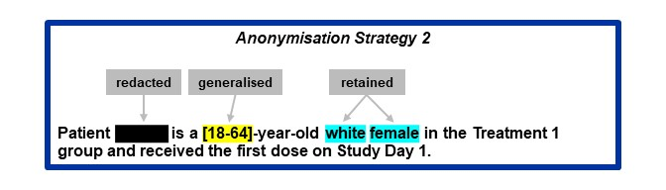
Figure 1. This example uses four different anonymisation techniques. The subject ID has been redacted, the age has been generalised, the race and gender has been retained. This strategy has retained most of the data utility.
Example: Redaction, Retention
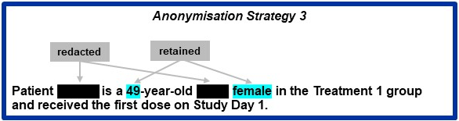
Figure 2. In this example, the subject ID and race has been redacted. The rest of the identifiers have been retained. This strategy has retained some data utility.

Example: Redaction
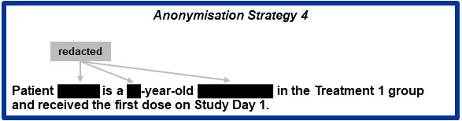
Figure 3. In this example, a targeted redaction strategy has been utilised to continue protecting patient privacy in the instance generalisation, retention and psuedonymisation cannot be used. This strategy has retained minimal data utility. Regulators prefer redactions to be targeted to only cover identifiers and will require the Data Controller to fill a deviation if blanket redactions that cover large portions of the text are used. Blanket redactions should only be considered as a last resort in extreme cases where low risk is not possible otherwise and this decision needs to be robustly justified in the anonymisation report.

8: Disclaimer:
The opinions expressed in this document are those of the authors and should not be construed to represent the opinions of PHUSE members; respective companies/organizations or Regulator’s views or policies. The content in this document should not be interpreted as a data standard and/or information required by Regulatory Authorities.

10: Project Contact Information:
- Lauren Hepburn
- Abby McDonell
- Devaki Thavarajah
- Mahesh Swaminathan
- Use Email: workinggroups@phuse.global

11: Acknowledgments:
Mekhala Acharya, Asmita Anil, Sanjay Bagani, Sarah Balay, Cara Campora, Holly Curry, Dhiraj Ravjibhai Dabhi, Shalini Dwivedi, Rama Empati, Swagata Ghosh, Manohara Basoor Halasiddappa, Anitha Isaiah, Thomas Kalfas, Shirisha Kanthala, Michael McTaggart, Muhammad Oneeb Rehman Mian, Sharon Conder Niedecken, Pooja Phogat, Viveka Rydell-Anderson, Taniya Rade, Mithun Kumar Ranga, Benjamin C. Shim, Shweta Srivastava, Abhinav Srivastva, Tamsin Sargood, Brenda Tiffin, Simin Takidar, Thomas Wicks, Sophia Zilber.
The Working Group would like to thank representatives from both Health Canada and the European Medicines Agency for their support as observers in the creation of the Good Transparency Practice White Paper.

